**CONTENTS**

1. **PART I:** 
   1. **SUBMISSION OF APPLICATION BY COMPUTER OPERATOR**
2. **PART II:**
   1. **TRACKING OF APPLICATION STATUS BY COMPUTER OPERATOR**
3. **PART III:**
   1. **ISSUANCE OF CERTIFICATE BY PRADHAN GRAM PANCHAYAT**
4. **PART IV:**
   1. **REPORTING AND CERTIFICATE DISPATCH BY PRADHAN GRAM PANCHAYAT**

**USER MANUAL**

**FLOWCHART**

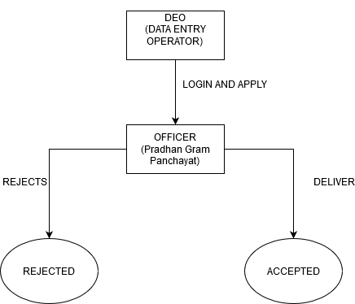

**PART I:**

**SUBMISSION OF APPLICATION: (BY COMPUTER OPERATOR)**

STEP 1:

**At first login to Service plus web portal: (**[http://tathyasathi.bangla.gov.in](http://tathyasathi.bangla.gov.in/))

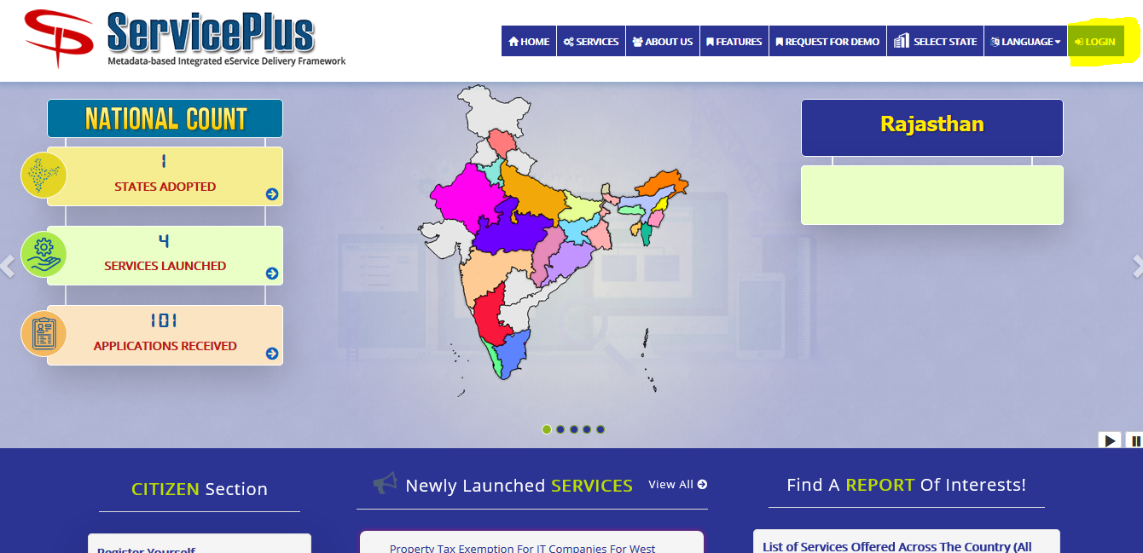

STEP 2:

Login as highlighted with the required credentials such as User ID and Password as shown below with the captcha.

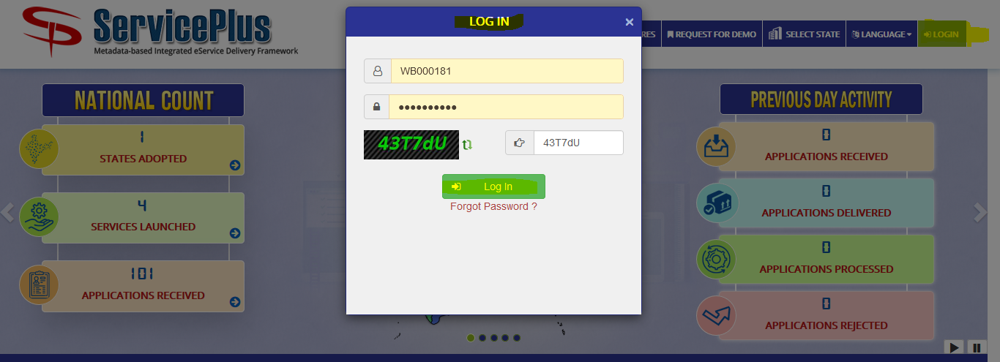

STEP 3:

After Logging In select “**Apply for Services**” from the dashboard and select “**View all available services**” to view your submitted service.

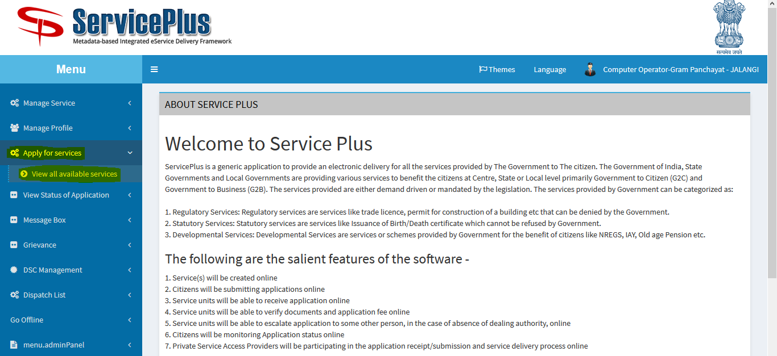

STEP 4:

After selecting “**View all available services**” now select your “**Application for Issuance of Caste-cum-Income Certificate - GP**” to check your application.

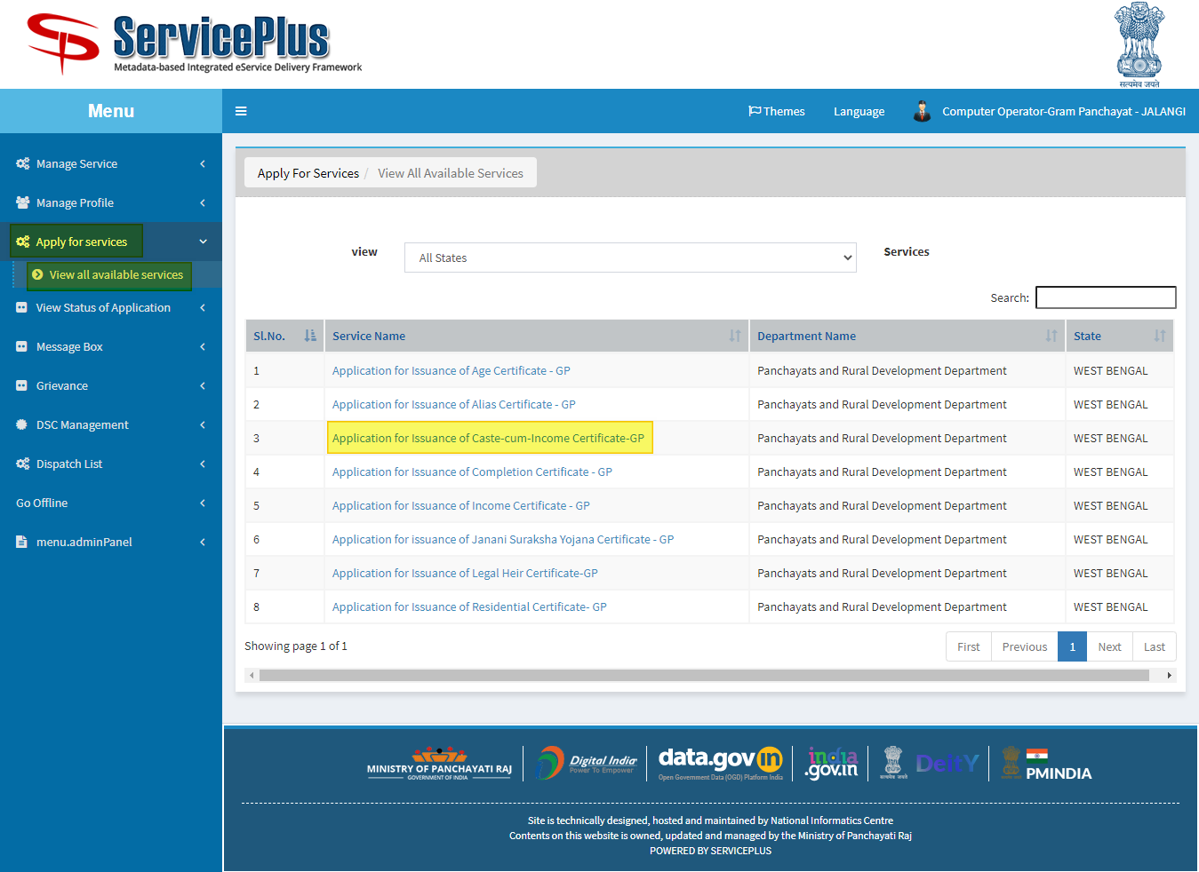

STEP 5:

Now fill in with the valid applicant’s details as required.

After filing the details, give the required captcha and submit the form.

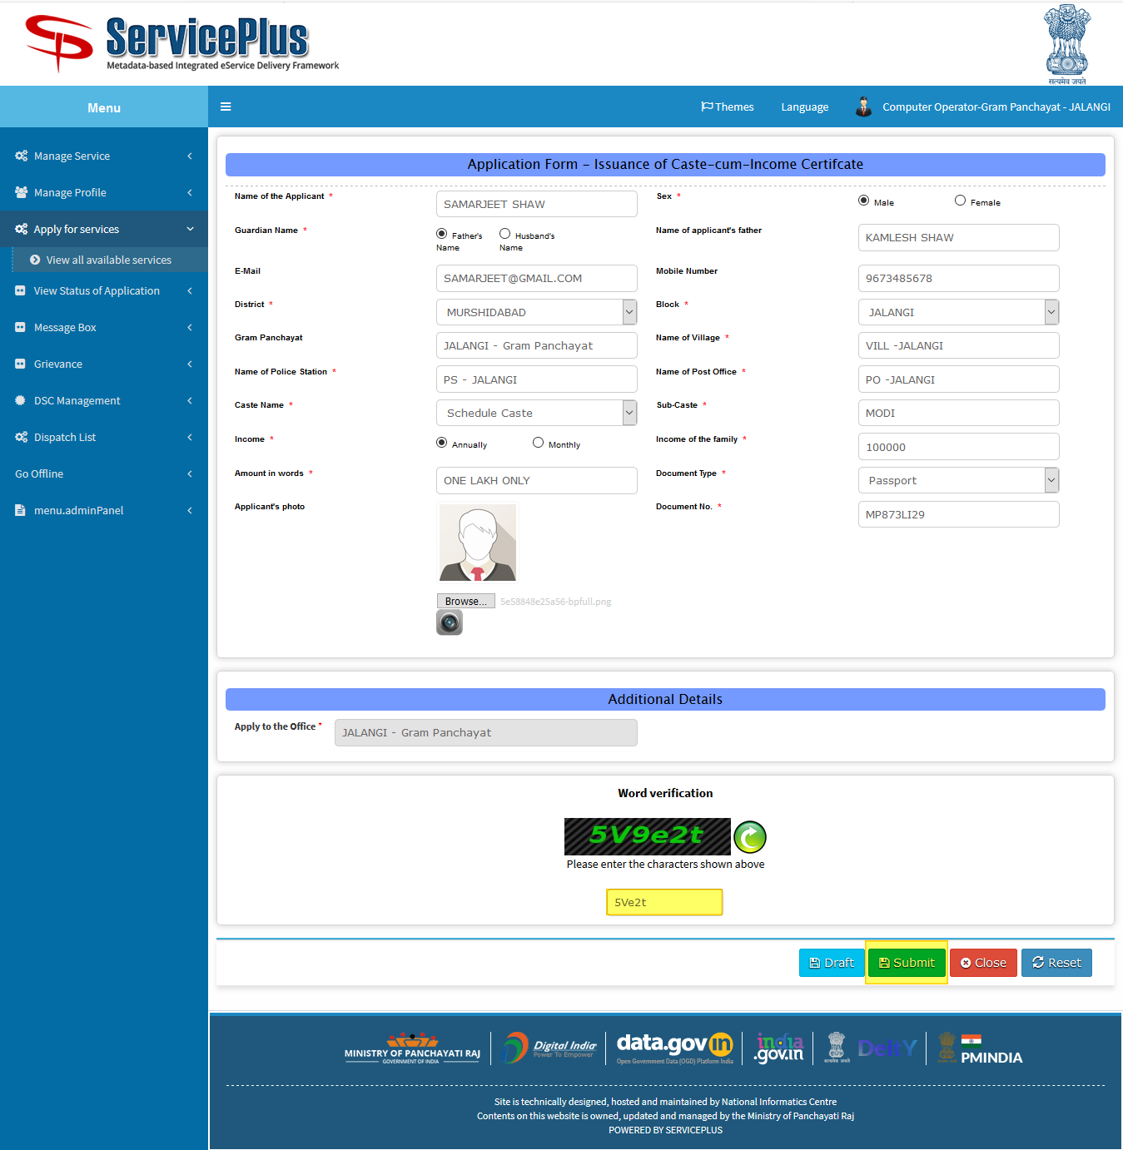

STEP 6:

This is preview after which you can re edit it or submit it.

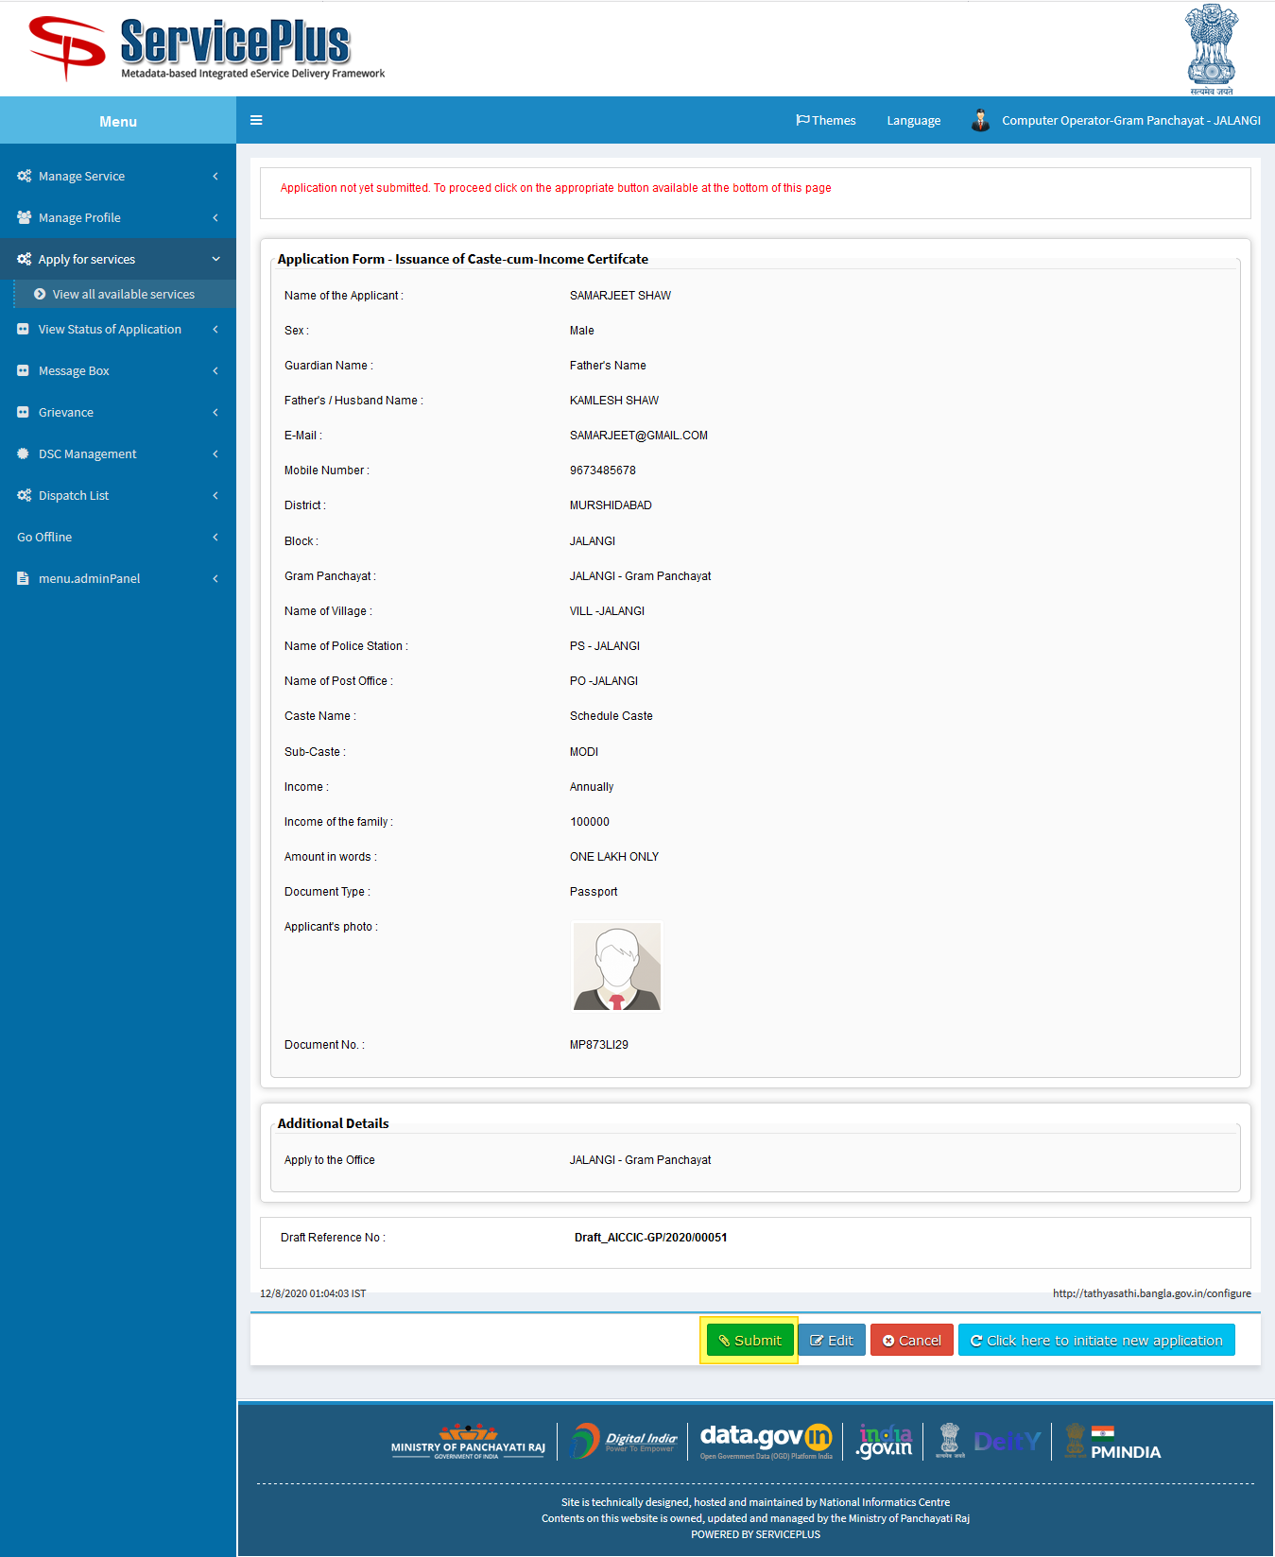

STEP 8:

This is the applicant’s acknowledgement slip which can be printed or downloaded as pdf.

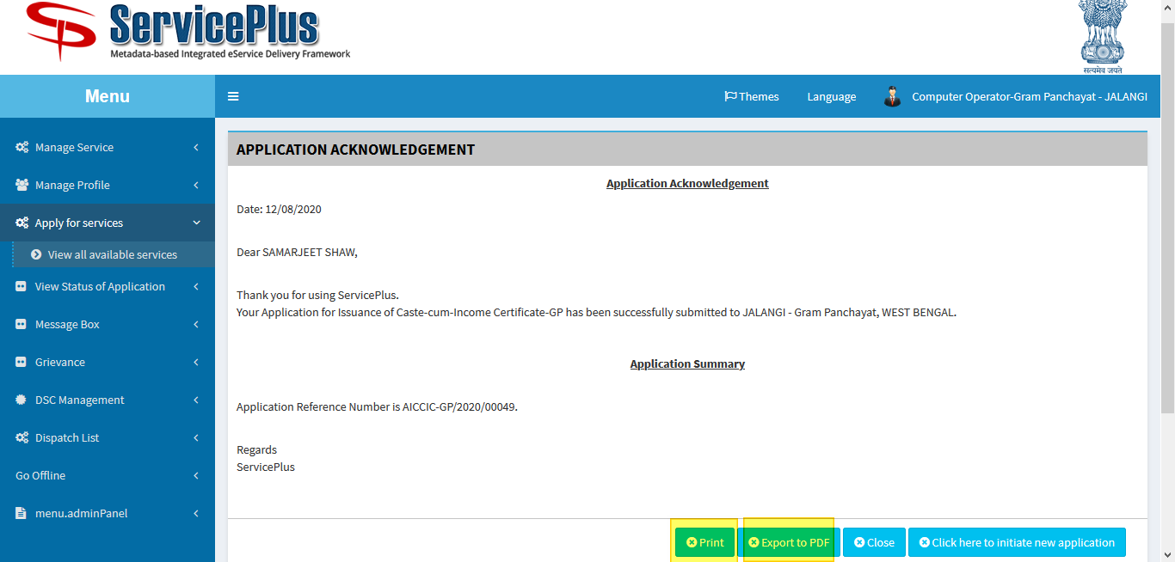

**PART II:**

**TRACKING FOR ISSUANCE OF APPLICATION CERTIFICATE:**

STEP 1:

The Applicant’s application can be tracked by going to “**View Status of Application**” and selecting “**Track application status**” by providing application ref. no: ********** and selecting “**Get Data**” button.

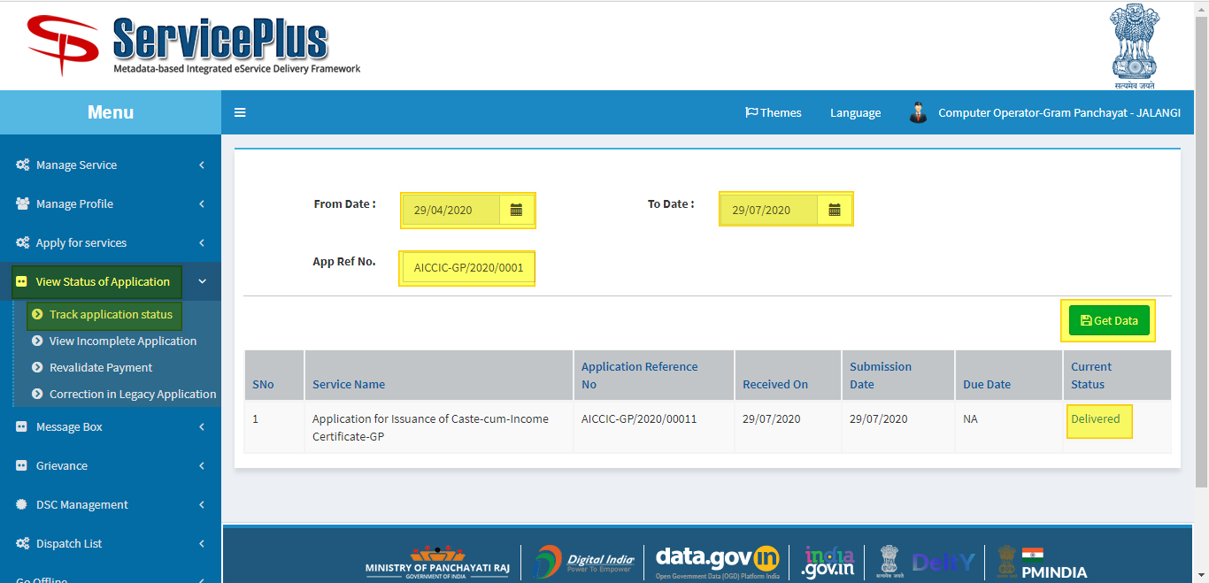

STEP 2:

After getting the list of data select the preferable Service Name which are delivered.

BY selecting delivered we can get the details of the Caste-cum-Income certificate.

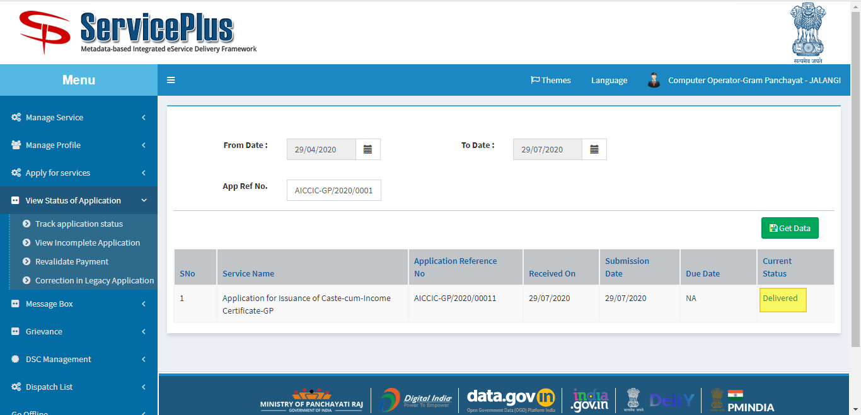

STEP 3:

After selecting delivered a modal pops up with applicant’s all details such as their caste-cum-income certificate provided, application submission form etc. which can be downloaded for future use.

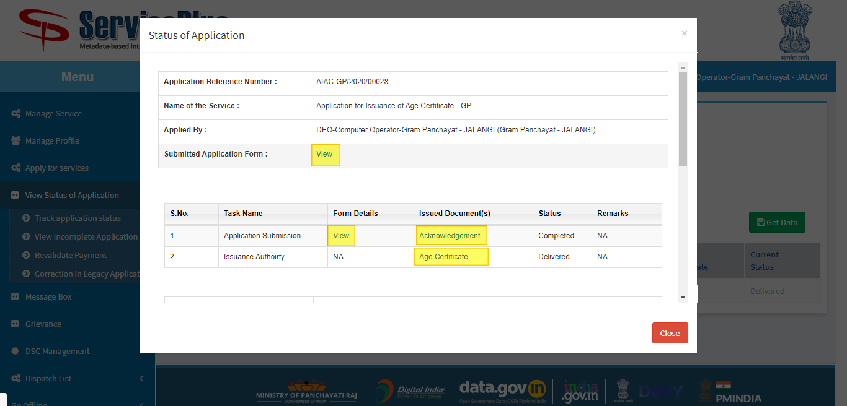

STEP 4:

A Sample of Caste-cum-Income certificate is been provided which can be get by selecting the Caste-cum-Income certificate.

The QR code and ref: no. is unique.

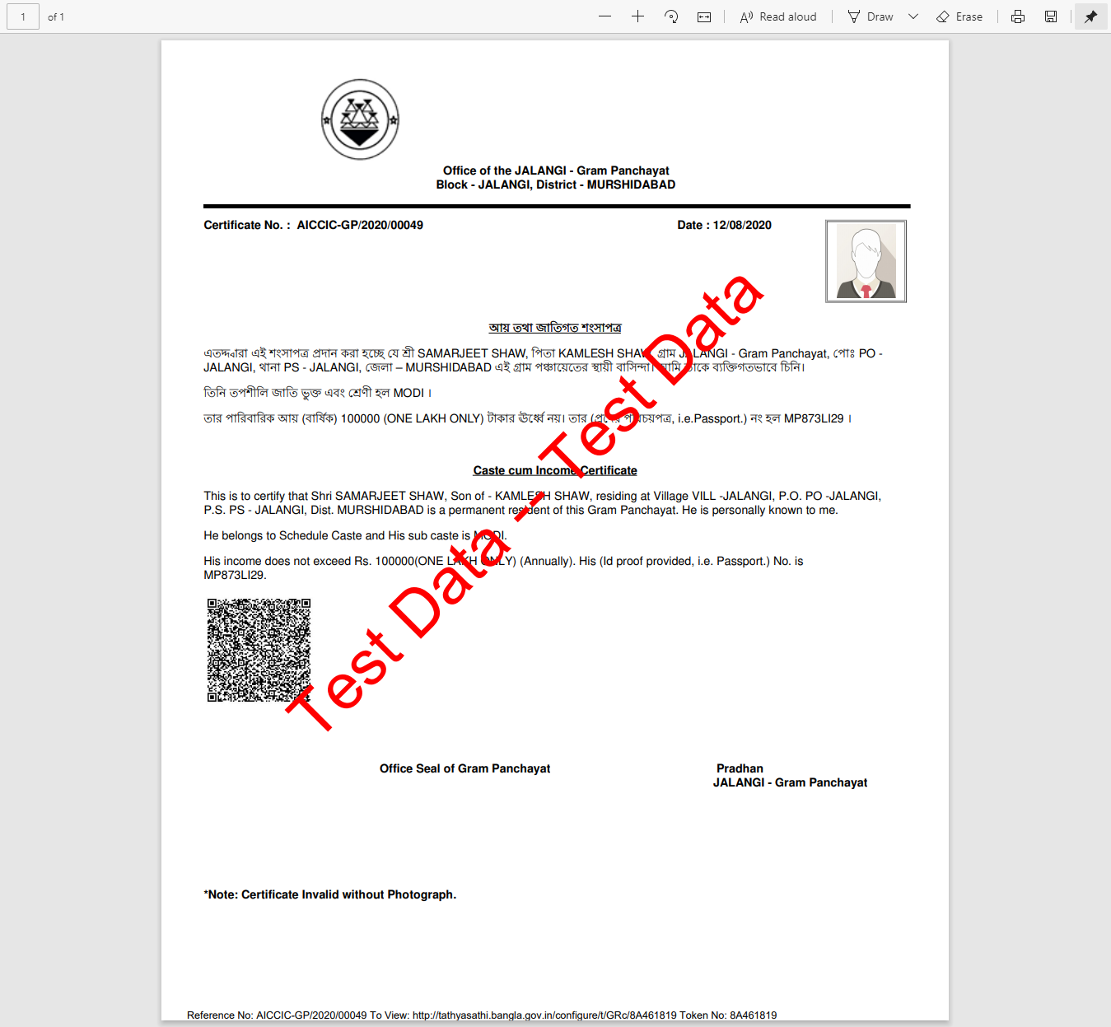

**PART III:**

**ISSUANCE OF CASTE-CUM-INCOME CERTIFICATE: (By PRADHAN GRAM PANCHAYAT)**

STEP 1:

**At first login to Service plus web portal: (**[http://tathyasathi.bangla.gov.in](http://tathyasathi.bangla.gov.in/))



STEP 2:

Login as highlighted with the required credentials such as User ID and Password as shown below with the captcha.

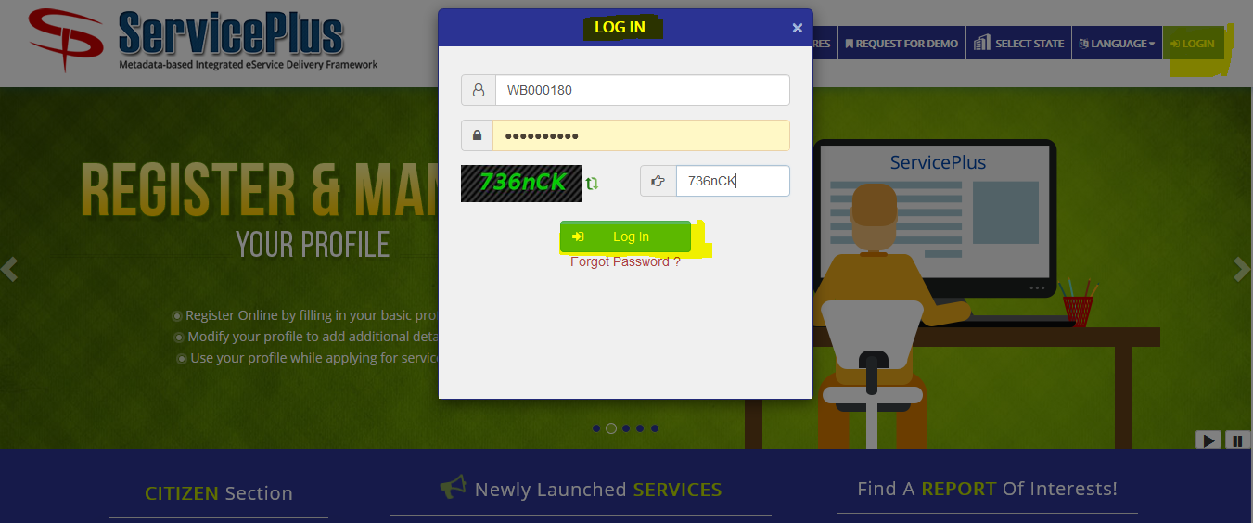

STEP 3:

Here the applicant’s application can be accepted or rejected by going to “**Message Box**” and selecting “**Inbox**”.

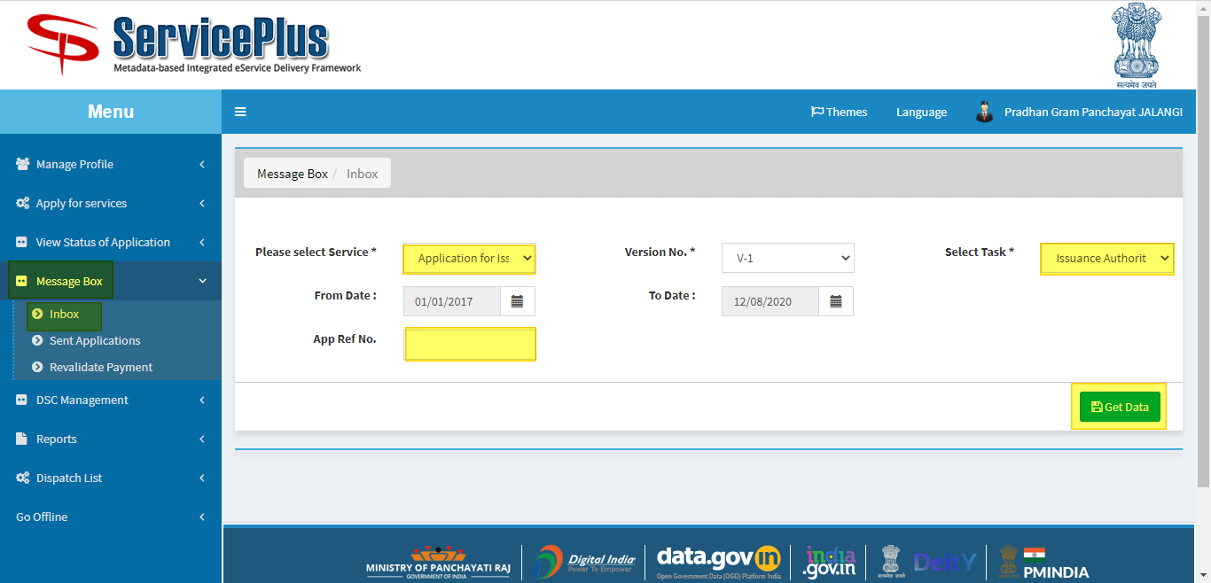

STEP 4:

Here the Pradhan has to select service “**Application for Issuance of Caste-cum-Income Certificate - GP**” and fetch data by hitting the button **“Get Data**” which leads to the list of pending applications.

Here “**Application Number**” can be selected to get the applicant’s detail and “**Take Action/Pull**” would lead to a new page for issuing the certificate or rejecting it.

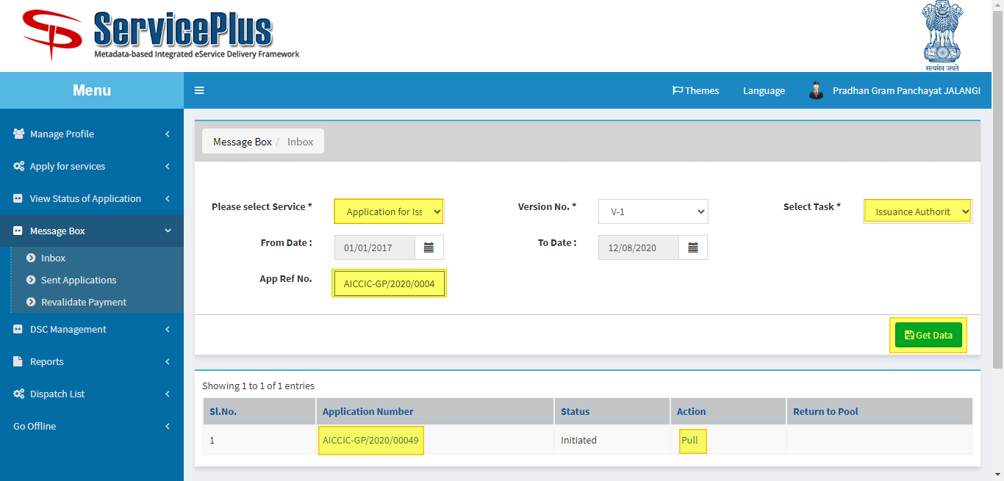

STEP 5:

Here the Pradhan has the right to see the applicant’s application form by selecting the certificate icon.

It can be further submitted or edited or cancelled.

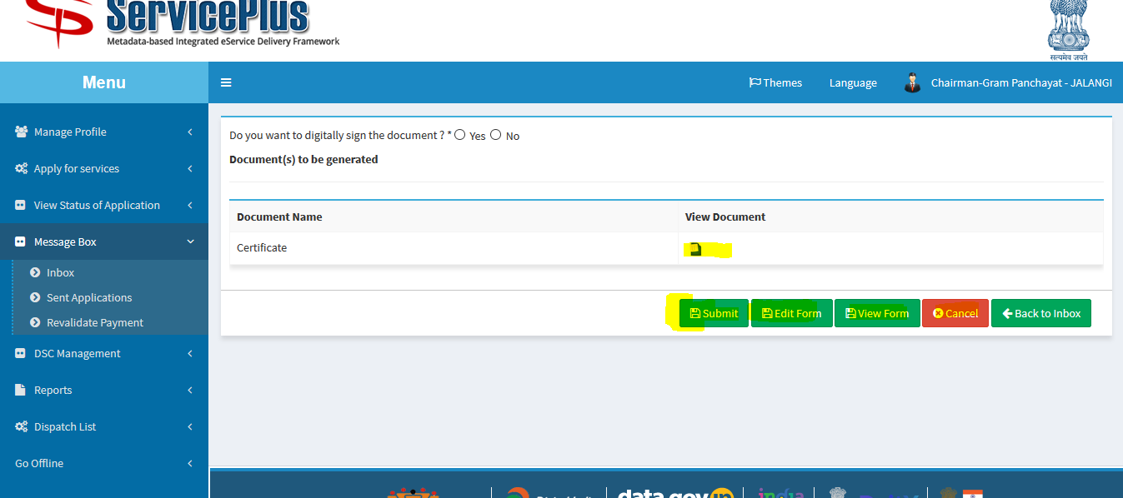

STEP 6:

By selecting edit button it leads to open this page.

By selecting Action of rejecting or delivering the certificate with the respective remark can lead to form rejection or approval.

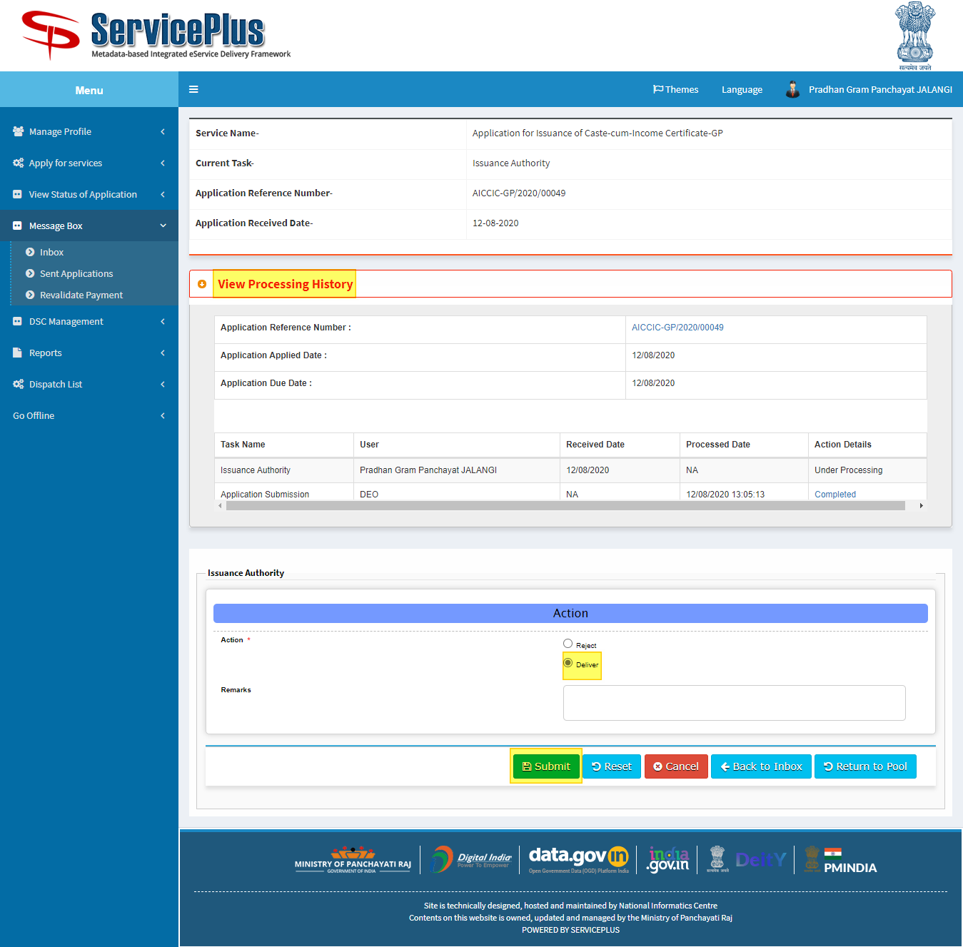

STEP 7:

By selecting “**View Processing History**” the application history can be seen such as applied date, issuance authority name with date etc.

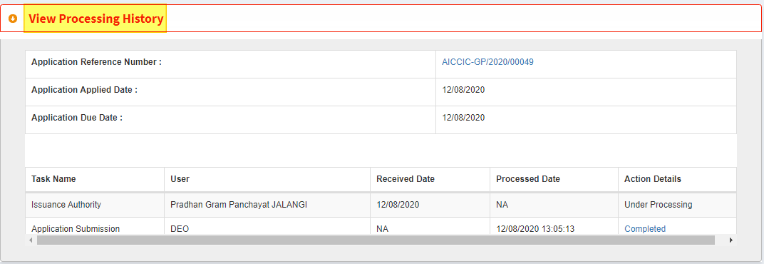STEP 8:

By selecting view form a pop up opens which shows the state of the application.

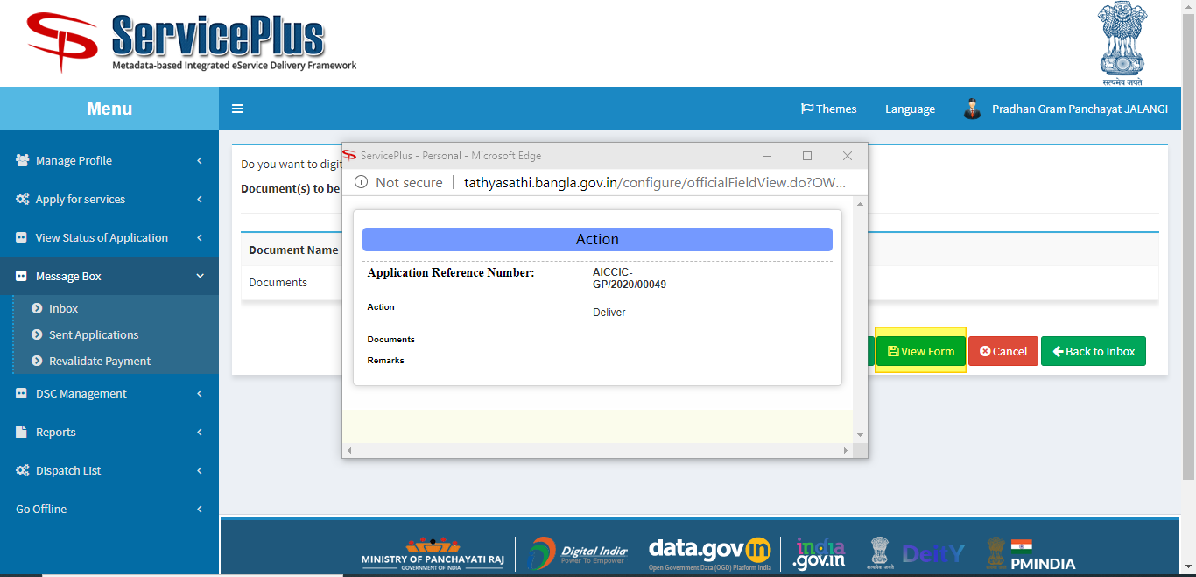

STEP 9:

After completion of all this for the final submission would be done by selecting the radio button for getting the digitally signed document or not.

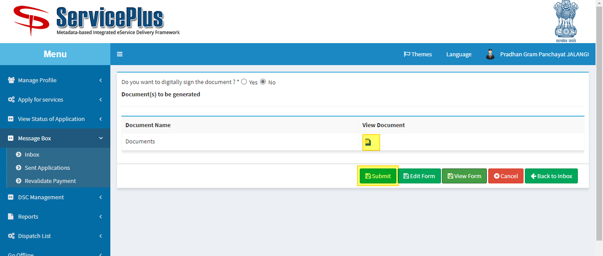

STEP 10:

Like this other application can be approved or rejected by the Pradhan authority.

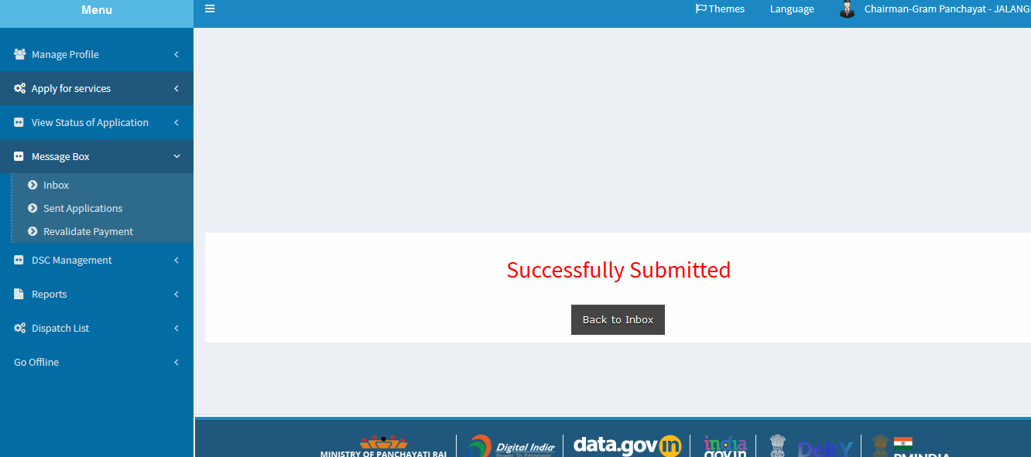

**PART IV:**

**Reporting And Certificate Dispatch: (By PRADHAN GRAM PANCHAYAT)**

**STEP 1:**

This is the dashboard showing the Total no. of application ,No. of pending Applications, Delivered Applications and Processed Application after login.

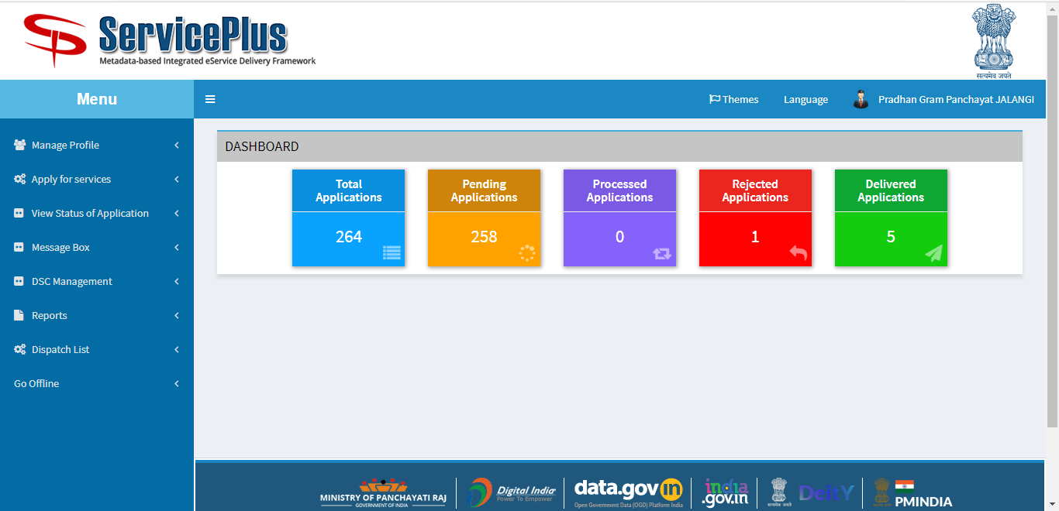

Login and goto “**Dispatch List**” and select “**View Delivered Services**” which lead to open to get the data.

We can “**select the service**” and we can also get the data in respect of date from “**from date - to date**”.

There is a option to get the data in respect of particular “**App Ref No.**” too.

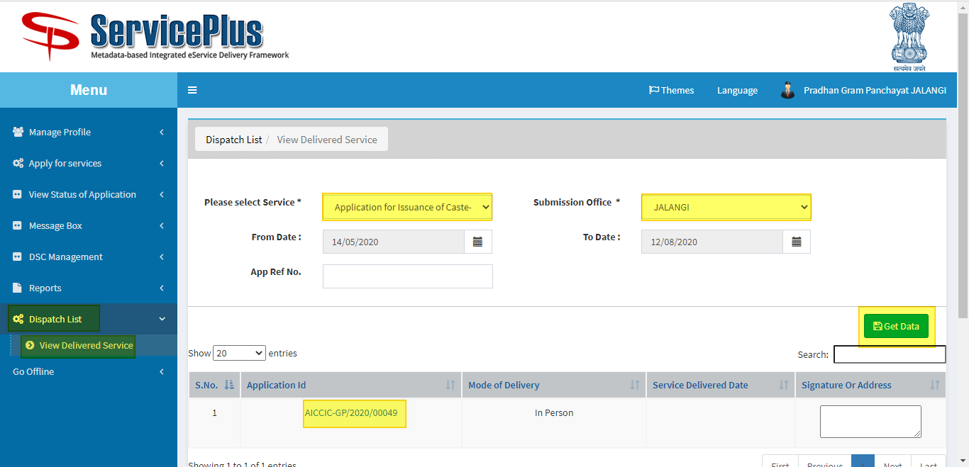

**STEP 2:**

Select the “**Application ID**” to get the dispatched certificate like below.

We can get a printout by the print button given there.

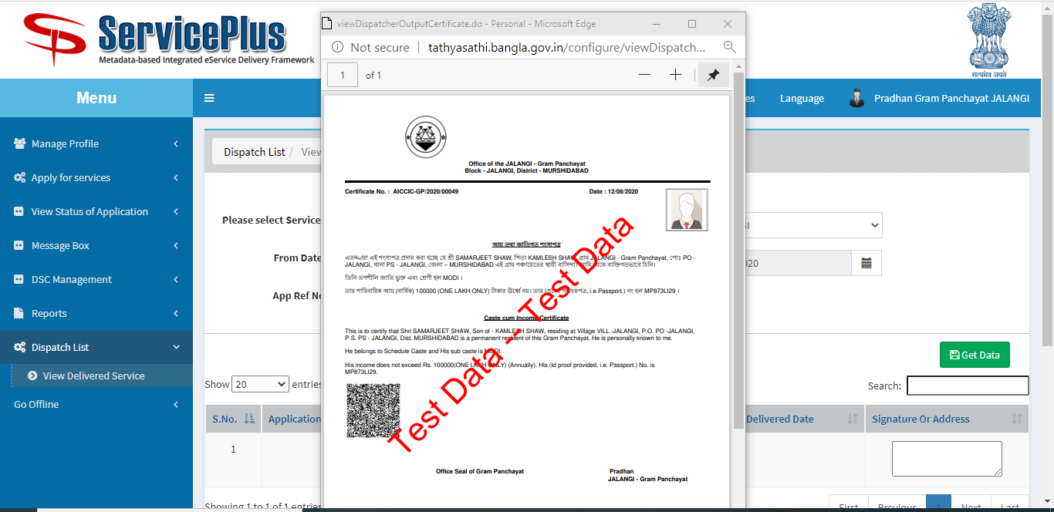

**STEP 3:**

Select to print from the list.

